Notice and Note Handout
Signpost | What it Means | Questions & Sentence Stems
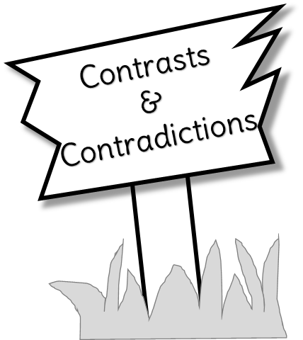 | A character’s thoughts or actions are opposite of what you would expect, or they surprise you.  An event or setting feels like it doesn’t belong. This might help you to identify the problem or conflict in the story. | What did you think would happen? How is this different from what happened?  Why did the character act or feel that way?  Why is the character doing this?
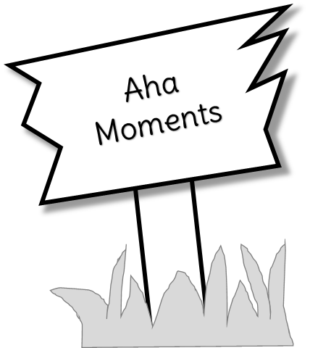 | The moment when a character suddenly figures out something important that changes them or the plot. The character figures out the problem, which leads you to solve the conflict. The character recognizes or learns a lesson, leading you to important clues to determine the theme. | “{Character} now knows…”  “{Character} realized…”  “{Character} suddenly understood…”  Why might this realization be important?
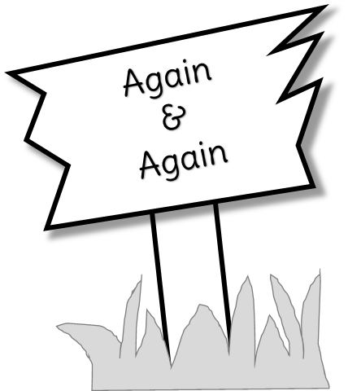 | When an image, word, or situation is repeated often. You begin to wonder why the author is repeating the image, word, or situation. It must be important! | What is being repeated?  Why might the author bring this up again and again?  What other details help us to understand the importance of this repeated information?
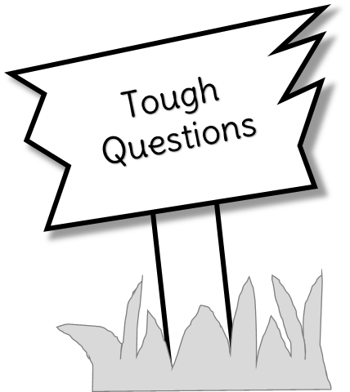 | The moment when a character stops and asks themselves or someone they trust a tough question. Usually a “I wonder…” or a “Why…” type of question. These questions sometimes cannot be answered. The answers will tell you about the conflict in the text and might give you ideas about what will happen next in the story. | What does this tough question make me wonder?  How might this decision change what happens in the story?
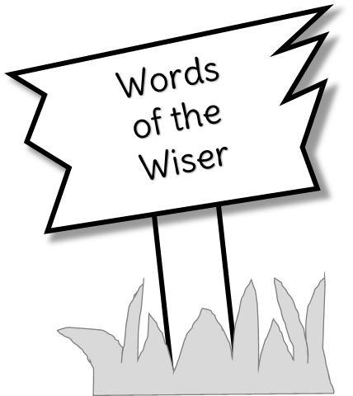 | When an older and wiser character offers a life lesson of some sort to the main character. Whatever this lesson is, might be the theme of the story. | What event prompted the character giving this advice?  How could this advice affect the character?  How did the main character react to the advice given?
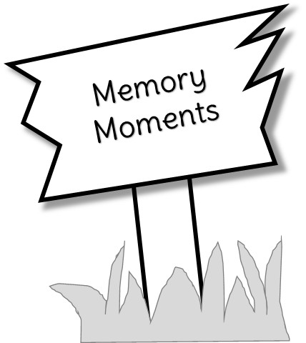 | When you read a flashback or pause in the story. The character might reflect back on a memory. These moments usually hold important information, even if it hasn’t been revealed why it is important yet. | What event triggered the memory?  Why might this memory be important?  How does the main character react to the memory?

